**Calculator Assumed**

**Applications of Differentiation 1**

Time: 45 minutes

Total Marks: 45

Your Score: / 45



**Question One: [3, 2, 2, 2 = 9 marks]**

When a beer is poured it has a foamy white froth on top of the beer. If left to sit, this froth slowly disappears and the reduction in froth bubbles is modelled by continuous exponential decay.

A beer is poured and the initial height of the froth is 2 cm. One minute later the height of the froth is 14.13215 mm.

1. If the height of the froth in mm, *H* can be modelled by  , *t* seconds after the beer is poured, determine the values of  and  .
2. Determine when the height of the froth is half its initial height.
3. Calculate the average rate of change of the height during the second minute.
4. Calculate the instantaneous rate of change of the height after 24 seconds.

**Question Two: [5, 3, 2, 3 = 13 marks]**

Consider the function  .

1. Use calculus methods to determine the coordinates and nature of any stationary points.
2. Use the second derivative to locate the points of inflection of  .
3. As  describe the behaviour of .
4. Hence graph .

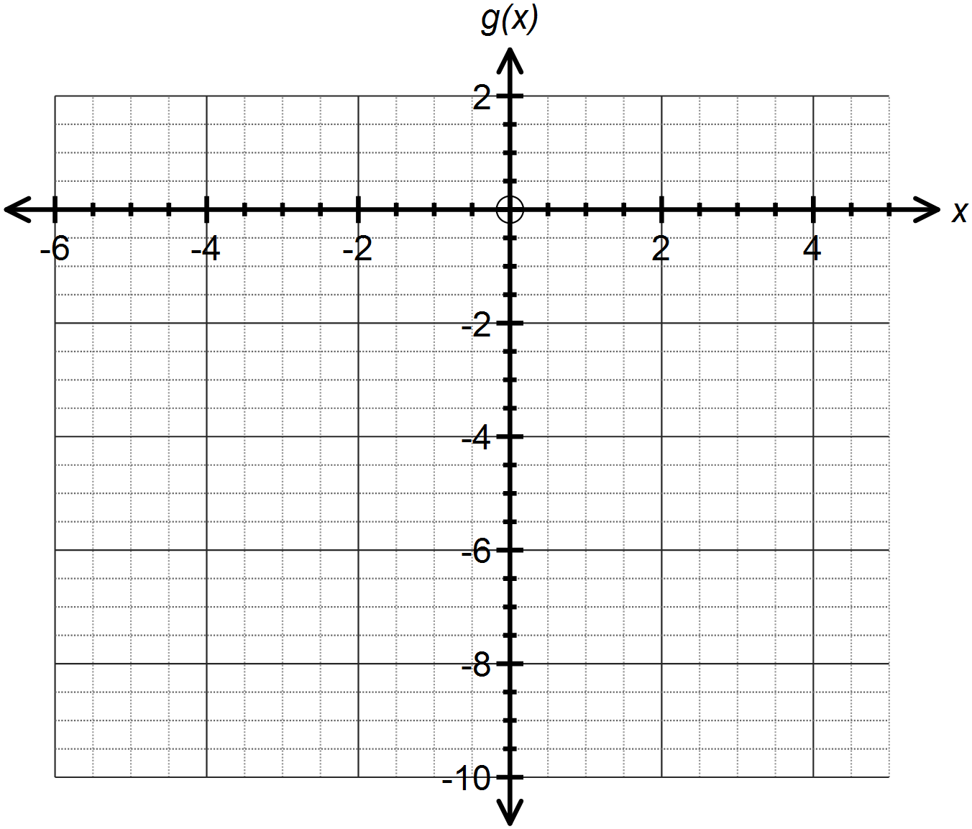

**Question Three: [1, 2, 1, 2, 1, 2, 1, 2, 2 = 14 marks]**

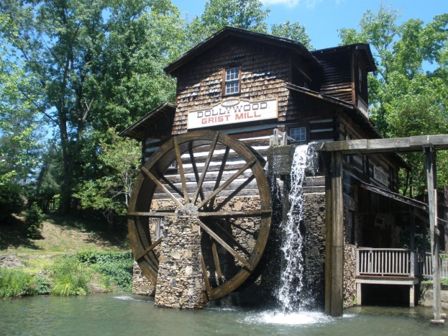An old waterwheel, 14 m in diameter, was used as an energy source to operate mechanisms to grind grain into flour in a flour mill.

When the water is in full flow, the wheel turns a full rotation in 20 seconds.

The vertical motion of a point on the wheel can be modelled by the function .

1. State the value of A.
2. Determine the value of *b*.
3. What is the initial vertical position of the point on the waterwheel?
4. Calculate  and describe its significance.
5. Determine an expression for the instantaneous rate of change of the vertical motion of a point with respect to time.
6. Hence calculate  and describe its significance.
7. Determine an expression which models the acceleration of the point on the wheel.
8. Determine when the speed of the point on the wheel is at a maximum during the first minute of motion.
9. At which heights in the vertical motion of the point does the waterwheel experience zero acceleration.

**Question Four: [2, 3, 4= 9 marks]**

The Gateway Arch in Saint Louis, Missouri, USA is pictured below.

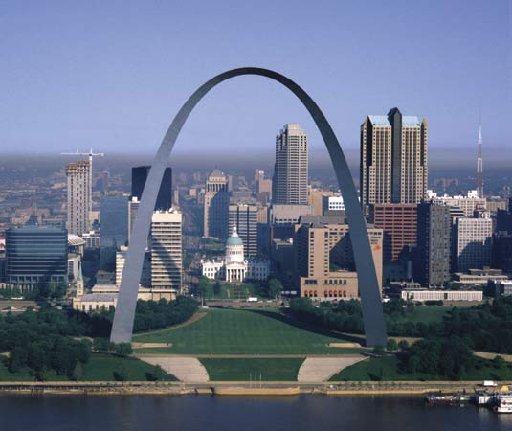The shape of this arch is not parabolic, but rather is modelled by what is known as a catenary curve.

There are many functions that can represent a catenary curve including  , the hyperbolic cosine function, and 

The Gateway Arch can be modelled by the equation  , where *h* is the height in feet and *x* is the horizontal distance across from the centre of the arch.

1. Express the equation that models the Gateway Arch in the form .
2. How wide is the arch, in feet, at 600 feet above the ground?
3. Use calculus methods to determine the maximum height of the arch.

**SOLUTIONS**

**Calculator Assumed**

**Applications of Differentiation 1**

Time: 45 minutes

Total Marks: 45

Your Score: / 45



**Question One: [3, 2, 2, 2 = 9 marks]**

When a beer is poured it has a foamy white froth on top of the beer. If left to sit, this froth slowly disappears and the reduction in froth bubbles is modelled by continuous exponential decay.

A beer is poured and the initial height of the froth is 2 cm. One minute later the height of the froth is 14.13215 mm.

1. If the height of the froth in mm, *H* can be modelled by  , *t* seconds after the beer is poured, determine the values of  and  .



1. Determine when the height of the froth is half its initial height.



1. Calculate the average rate of change of the height during the second minute.



1. Calculate the instantaneous rate of change of the height after 24 seconds.



**Question Two: [5, 3, 2, 3 = 13 marks]**

Consider the function  .

1. Use calculus methods to determine the coordinates and nature of any stationary points.



1. Use the second derivative to locate the points of inflection of  .



1. As  describe the behaviour of .



1. Hence graph .

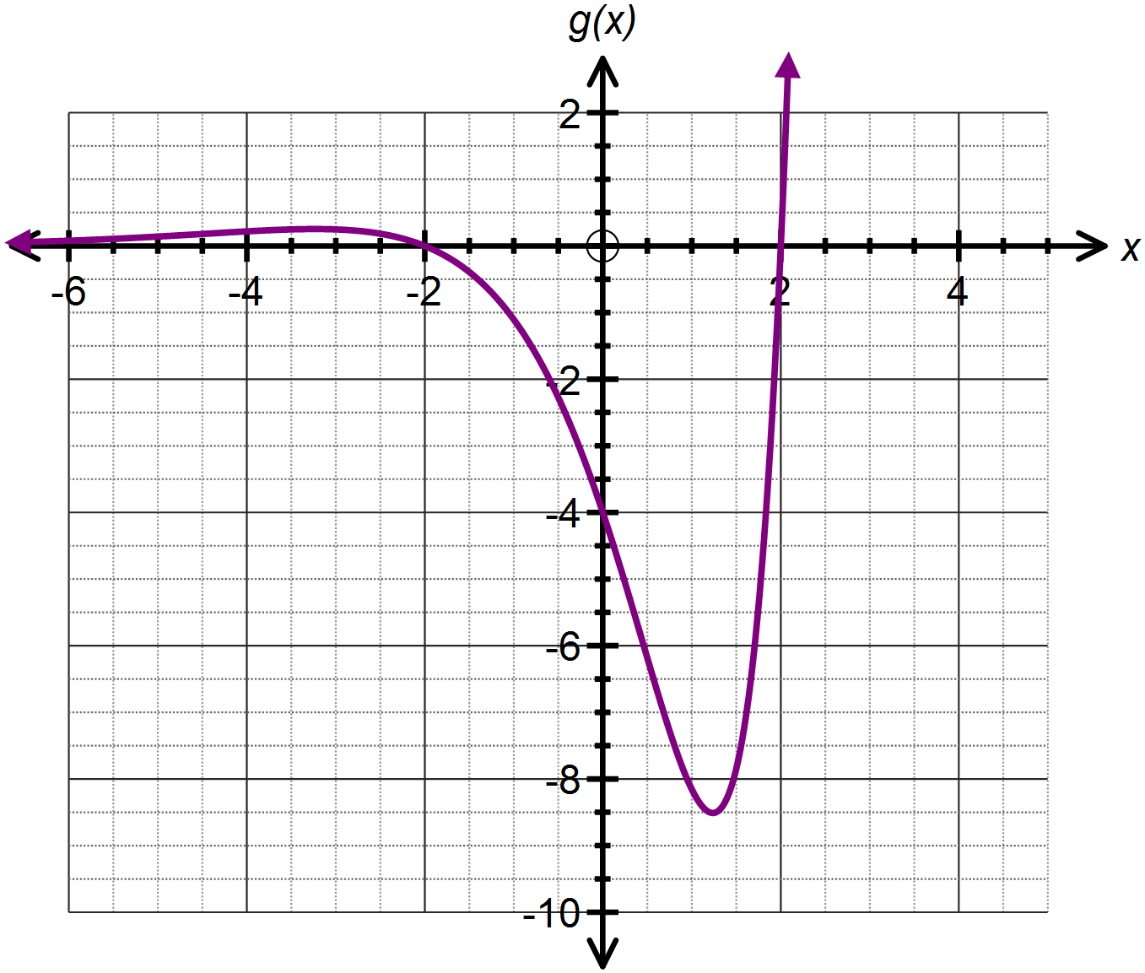



**Question Three: [1, 2, 1, 2, 1, 2, 1, 2, 2 = 14 marks]**

An old waterwheel, 14 m in diameter, was used as an energy source to operate mechanisms to grind grain into flour in a flour mill.

When the water is in full flow, the wheel turns a full rotation in 20 seconds.

The vertical motion of a point on the wheel can be modelled by the function .

1. State the value of A.



1. Determine the value of *b*.



1. What is the initial vertical position of the point on the waterwheel?





Therefore located directly left of the centre of the wheel.

1. Calculate  and describe its significance.



The point on the wheel is at water level.

1. Determine an expression for the instantaneous rate of change of the vertical motion of a point with respect to time.



1. Hence calculate  and describe its significance.



The vertical motion of the wheel is momentarily stationary.

1. Determine an expression which models the acceleration of the point on the wheel.



1. Determine when the speed of the point on the wheel is at a maximum during the first minute of motion.



1. At which height(s) in the vertical motion of the point does the waterwheel experience zero acceleration.

Whenever the point on the wheel is directly left or right of the centre of the wheel, that is, 7m above the water level.

**Question Four: [2, 3, 4= 9 marks]**

The Gateway Arch in Saint Louis, Missouri, USA is pictured below.

The shape of this arch is not parabolic, but rather is modelled by what is known as a catenary curve.

There are many functions that can represent a catenary curve including  , the hyperbolic cosine function, and 

The Gateway Arch can be modelled by the equation  , where *h* is the height in feet and *x* is the horizontal distance across from the centre of the arch.

1. Express the equation that models the Gateway Arch in the form .



1. How wide is the arch, in feet, at 600 feet above the ground?



Therefore 172 feet wide.

1. Use calculus methods to determine the maximum height of the arch.

